**Project Design Phase-II**

**Data Flow Diagram & User Stories**

|  |  |
| --- | --- |
| Date | 1 November 2023 |
| Team ID | Team- 592183 |
| Project Name | Disease Prediction Using Machine Learning |
| Maximum Marks | 4 Marks |

**Data Flow Diagrams:**

The Disease Prediction Using Machine Learning project unfolds through a systematic pipeline designed to enhance healthcare outcomes and foster inclusivity. Commencing with the input of diverse health data, the project embarks on a series of vital steps in disease prediction. The project begins by gathering a diverse array of healthcare datasets, including electronic health records, medical images, and lifestyle data. Rigorous preprocessing techniques are employed to ensure data quality and standardization. To enhance the model's ability to generalize, data augmentation techniques introduce variations within the dataset. The heart of the project lies in the training of a sophisticated machine learning model.

Rigorous evaluation metrics are employed to assess the model's performance. Iterative optimization is conducted to enhance accuracy, sensitivity, and specificity, ensuring the model's reliability in real-world healthcare scenarios. The culmination of the project is a user-friendly web application that empowers users to input health data seamlessly. The application leverages the trained model to predict disease risks and provides user-friendly visualizations to enhance understanding. Ensuring model interpretability is a key aspect. The application provides clear explanations for its predictions, fostering trust among healthcare professionals and patients by demystifying the decision-making process. The application allows users to receive real-time predictions, enabling timely interventions and proactive healthcare management.

The project is developed with a strong emphasis on ethical considerations. Measures are in place to identify and mitigate biases, promoting fairness and accountability in disease predictions. This comprehensive pipeline not only advances disease prediction using machine learning but also contributes to the broader goal of making healthcare more accessible and inclusive. By harnessing the power of advanced technology, the project strives to improve patient outcomes and facilitate a proactive approach to healthcare management.

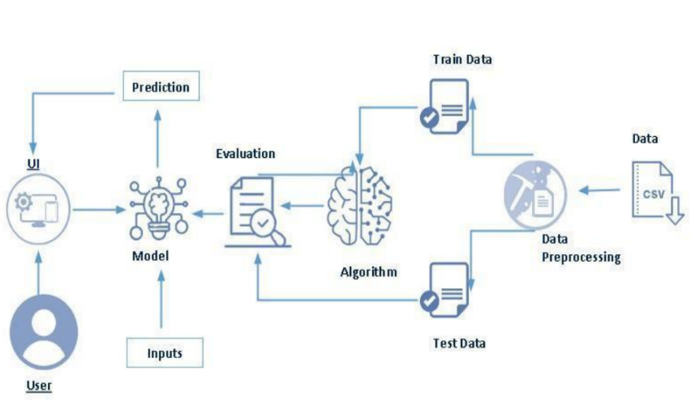

**User Stories**

Use the below template to list all the user stories for the product.

|  |  |  |  |  |  |  |
| --- | --- | --- | --- | --- | --- | --- |
| **User Type** | **Functional**  **Requirement**  **(Epic)** | **User Story Number** | **User Story / Task** | **Acceptance criteria** | **Priority** | **Release** |
| Customers | Registration | USN-1 | As a new user, I can register for the application by entering my email, password. | I can access my account / dashboard | High | Sprint-1 |
|  | Login | USN-2 | As a user, I can login into the application by entering email & password | I can login into the application | High | Sprint-1 |
|  | Accessibility | USN-3 | The platform is designed to be accessible to users with varying levels of health literacy, ensuring inclusivity. | I can access the application with ease | High | Sprint-2 |
|  | Prediction | USN-4 | Upon submitting my health data, the machine learning model processes the information to predict potential diseases or health risks. The prediction is based on advanced algorithms that analyze patterns and correlations within the dataset. | We can do prediction  Based on the symptoms provided. | High | Sprint-3 |
|  | Feedback | USN-5 | The development team actively incorporates user feedback to improve the accuracy of predictions, the clarity of explanations, and overall user satisfaction. | I can provide feedback about the application | High | Sprint-3 |